Week 2 - Let’s try something simple..

We as engineers always want to make things easy. Currently we are trying to solve for the problem of segmentation. Assume we have done all the bias field correction stuff and we have the final image to be segmented. We would like to try out a simple strategy for doing segmentation - K - Means Clustering.

# Task 1

Understanding the K Means Clustering Algorithm.

Learn Initialization Methods :

1. K Means ++

References :

1. <https://www.geeksforgeeks.org/k-means-clustering-introduction/>
2. <https://www.microsoft.com/en-us/research/uploads/prod/2006/01/Bishop-Pattern-Recognition-and-Machine-Learning-2006.pdf> - Pattern Recognition and Machine Learning. Chapter 9 - Only K - Means Clustering algorithm.

# Task 2

Hopefully you have covered the basics of K Means Clustering. Let’s implement it to segment the image below ( Reference : Pattern Recognition and Machine Learning, Bishop )

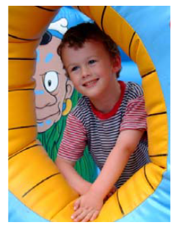

You have to implement the K Means Clustering algorithm in python ( You have to submit a jupyter notebook ).

1. Run the code on this image with k = 2, 3, 10.
2. Compare your results with those given in the book.

The above has to be done with K means ++ initialization.

Do the same with random Initialization method for k = 2, 3 , 10.

Your jupyter notebook must be **well commented** and **runnable.** All the six images must be individually coded in six different cells of the notebook. Don’t add code for saving the images in the notebook. Only use NumPy, Pandas, Matplotlib.

Questions to be answered in report.

1. Consider the image corresponding to k = 3 given in the book. The three major clusters are blue part, yellow part, and black part. Are you getting the same/similar results as those of book ? You can see that the face of the kid has been clustered along with the yellow pixels while the face of the cartoon figure has been clustered with the blue sky. Can you mathematically explain this result ? You can show the 3D plot of the distribution of the pixel intensity ( RBG ) by taking a small section of pixels from the face of both the figures and from the Yellow part in the original image for supporting your answer.
2. Look at the segmented T-shirt of the boy. The lining pattern is preserved while clustering. Don’t you think that the pixels of blue lines and white lines ( in the original image ) are close enough to be clustered together. What could be the reason for the preservation of lining pattern ?

# Have a break! Have a kitKat!

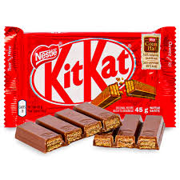

# Task 3 - Masking

Consider the image below obtained from Brain MRI. The only relevant pixels are ones that belong to the brain. We would like to come up with an automated ( or almost automated )way to make a boolean mask of the same size as this image where 1 means that the pixel is part of the brain and 0 means that the pixel is not part of the brain.

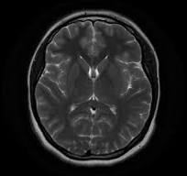

You have to submit a jupyter notebook for the same. Again well commented and runnable.

**Remember** that you have to get rid of the outer shell of the brain also because we are doing tissue segmentation and we don’t want to consider that shell.

Finally you have to run your K - Means Clustering algorithm considering only the pixels that are part of brain. Use K means ++ for initialization and K = 3 as the number of clusters. This code has to be within the same jupyter notebook below the masking code. Again no fancy libraries for this purpose. I would advice you to analyze the intensity distribution and try to come up with good masking method. ( that would be like almost automated rather than automated but it is far better than doing masking manually ).

# Report + Code Submission

All the questions has to be answered in a report ( Preferably google doc ). The theoretical analysis and reasoning behind what you have done has to be given for task 3 ( in the report itself ). Make your own github repositories for the project, keep it private and me as a collaborator ( NavyaHissaria, [navyahissaria2005@gmail.com](mailto:navyahissaria2005@gmail.com) ). Put all your report + code stuff in this repo. Hope you enjoy this task.

# As a side note to our friendly mentees 😀



# So Enjoy Your Vacations !